TOPIC 1 - Cryptography
Slide 3 - Cryptography
Cryptography is an indispensable tool for protecting information in computer systems.
Cryptography is the science of making and breaking secret codes
By storing and transmitting encrypted data, so only the intended recipient can read or process it, protection is given to organizational data.
It uses mathematical methods to transform data, with the intention of hiding their content or protecting them against modification.
It has a long history. In 1975, the first data encryption standard was adopted. It was proposed by IBM and called DES (Data Encryption Standard).

Slide 4 - A Brief History of Cryptography
Cryptography is a young science.
Though it has been used for thousands of years to hide secret messages, systematic study of cryptology as a science (and perhaps an art) just started around one hundred years ago.
The first known evidence of the use of cryptography (in some form) was found in an inscription carved around 1900 BC into the wall of a tomb from the Old Kingdom of Egypt. The scribe used some unusual hieroglyphic symbols here and there. The purpose was not to hide the message but perhaps to change its form. Although the inscription was not a form of secret writing, it incorporated some sort of transformation of the original text, and is the oldest known text to do so.
Some clay tablets from Mesopotamia later are clearly meant to protect information—one dated near 1500 BC was found to encrypt a craftsman's recipe for pottery glaze, presumably commercially valuable. Furthermore, Hebrew scholars made use of simple monoalphabetic substitution ciphers (such as the Atbash cipher) beginning perhaps around 600 to 500 BC.
The ancient Greeks are said to have known of ciphers. The scytale transposition cipher was used by the Spartan military, but it is not definitively known whether it was for encryption, authentication, or avoiding bad omens in speech. Another Greek method was developed by Polybius (now called the "Polybius Square")
Fast forwarding to around 100 BC, Julius Caesar was known to use a form of encryption to convey secret messages to his army generals posted in the war front. This substitution cipher, known as Caesar cipher, is perhaps the most mentioned historic cipher in academic literature.
During the 16th century, Vigenere designed a cipher that was supposedly the first cipher which used an encryption key.
At the beginning of the 19th century when everything became electric, Hebern designed an electro-mechanical contraption which was called the Hebern rotor machine. It uses a single rotor, in which the secret key is embedded in a rotating disc. The key encoded a substitution table and each key press from the keyboard resulted in the output of cipher text.
The Enigma machine was invented by German engineer Arthur Scherbius at the end of World War I, and was heavily used by the German forces during the Second World War.
Up to the Second World War, most of the work on cryptography was for military purposes, usually used to hide secret military information. However, cryptography attracted commercial attention post-war, with businesses trying to secure their data from competitors.
In the early 1970's, IBM realized that their customers were demanding some form of encryption, so they formed a "crypto group" headed by Horst-Feistel. They designed a cipher called Lucifer. In 1973, the Nation Bureau of Standards (now called NIST) in the US put out a request for proposals for a block cipher which would become a national standard. They had obviously realized that they were buying a lot of commercial products without any good crypto support. Lucifer was eventually accepted and was called DES or the Data Encryption Standard.
In 1997, NIST put out again a request for proposals for a new block cipher. It received 50 submissions. In 2000, it accepted one, and named it AES or the Advanced Encryption Standard. Today AES is a widely accepted standard used for symmetric encryption.
In recent times, advancements in Quantum computers have led us to think about Post Quantum Cryptography. In 2016 NIST declared a “call for proposals” seeking public help in designing quantum resistant algorithms which could help us “withstand the assault of a future quantum computer”. In 2020 NIST announced four finalists.

Slide 5 - Cryptography Terms
Modern cryptography uses secure algorithms to ensure that cybercriminals cannot easily compromise protected information. This results in data confidentiality (confidentiality is ensured) so that only the intended recipient can read the message.
Encryption: It is the process of locking up information using cryptography. Information that has been locked this way is encrypted.
Plaintext- This is the data that needs to be protected.Ciphertext- This is the encrypted, or unreadable, version of the plaintext.
Decryption: The process of unlocking the encrypted information using cryptographic techniques.
In cryptography, a cipher is an algorithm for performing encryption or decryption
Key: A secret like a password used to encrypt and decrypt information. There are a few different types of keys used in cryptography.
Steganography: It is actually the science of hiding information from people who would snoop on you. The difference between steganography and encryption is that the would-be snoopers may not be able to tell there’s any hidden information in the first place.
Cryptanalysis is a process of finding weaknesses in cryptographic algorithms and using these weaknesses to decipher the ciphertext without knowing the secret key (instance deduction).

Slide 6 - Cryptography figure
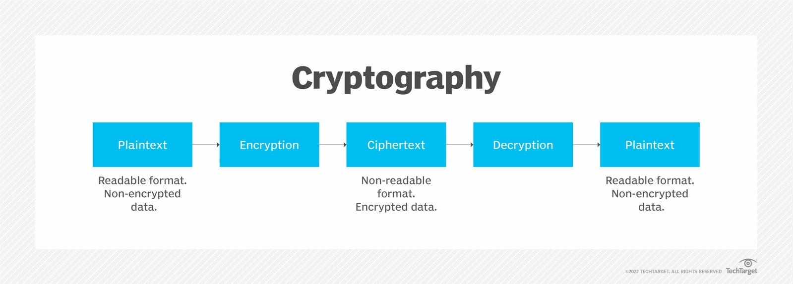
Cryptography is the process of encrypting and decrypting data.

Encryption is the process of scrambling data so that unauthorized people cannot easily read it.

When enabling encryption, readable data is called plaintext, while the encrypted version is encrypted text or ciphertext.

Encryption converts the plaintext readable message to ciphertext, which is the unreadable, disguised message. Decryption reverses the process.

Encryption requires a key, which plays a critical role in encrypting and decrypting a message. The person possessing the key can decrypt the ciphertext to plaintext.

Slide 7 - Cryptographic objectives
Modern cryptography concerns itself with the following four objectives:
Confidentiality. The information cannot be understood by anyone for whom it was unintended.
Integrity.The information cannot be altered in storage or transit between sender and intended receiver without the alteration being detected.
Non-repudiation. The creator/sender of the information cannot deny at a later stage their intentions in the creation or transmission of the information.
Authentication. The sender and receiver can confirm each other's identity and the origin/destination of the information.

Slide 8 - Creating Ciphertext
Key management is the most difficult part of designing a cryptographic system. Many cryptosystems have failed because of mistakes in their key management, and all modern cryptographic algorithms require key management procedures.
In practice, most attacks on cryptographic systems involve attacking the key management system, rather than the cryptographic algorithm itself.
Each encryption method uses a specific algorithm called a cipher to encrypt and decrypt messages.
A cipher is a series of well-defined steps used to encrypt and decrypt messages. There are several methods of creating ciphertext.

HOMEWORK

What happens if someone tries to break an encryption algorithm?

Is encryption really secure?

Can encryption algorithms be broken?

